Student Activity
27 Parallel circuits

TASK
To investigate how the addition of resistors in parallel affects the current and voltage in a circuit.

THEORY
The value of the total resistance in a parallel circuit can be found from the individual values.

EQUIPMENT
• power supply
• DC voltmeter (0–10 V) or voltage sensor
• DC ammeter (0–1 A) or current sensor
• 3 resistors of unknown resistance (resistors rated 2 W or more are suitable)
• connecting wires.

NOTES ON METHOD
ICT
Most current sensors have a 1 A range and are suitable for this experiment.
They are generally current-protected, but take care to check the manufacturer’s specifications, and use sensors with care.
Exceeding the maximum current rating will permanently damage ammeter or sensor.
Sample rate: As only comparative values are required, the default rates of your equipment or manual sampling are suitable.
Use a digital display to view and record instantaneous values.

1. Connect a circuit containing just one of the unknown resistors, the voltmeter, the ammeter (or voltage and current sensors) and the power supply.
Set the power supply to 6 V, turn it on, and measure the potential difference and current in the circuit.
Record these results.

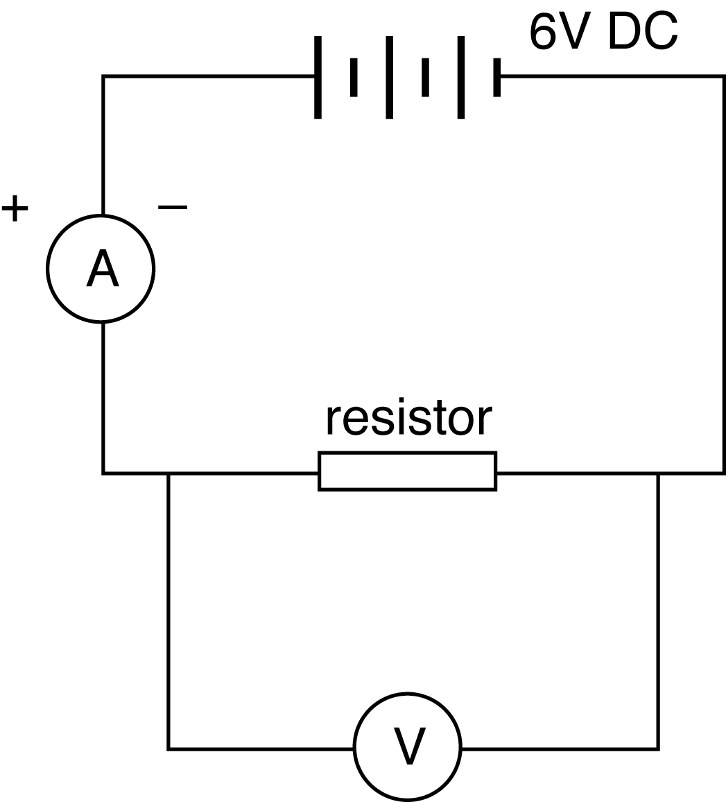
2. Add the second resistor to the circuit, in parallel with the first. Measure the total potential difference in the circuit, the total current across both resistors, and the current and potential difference for each resistor. Record these results.

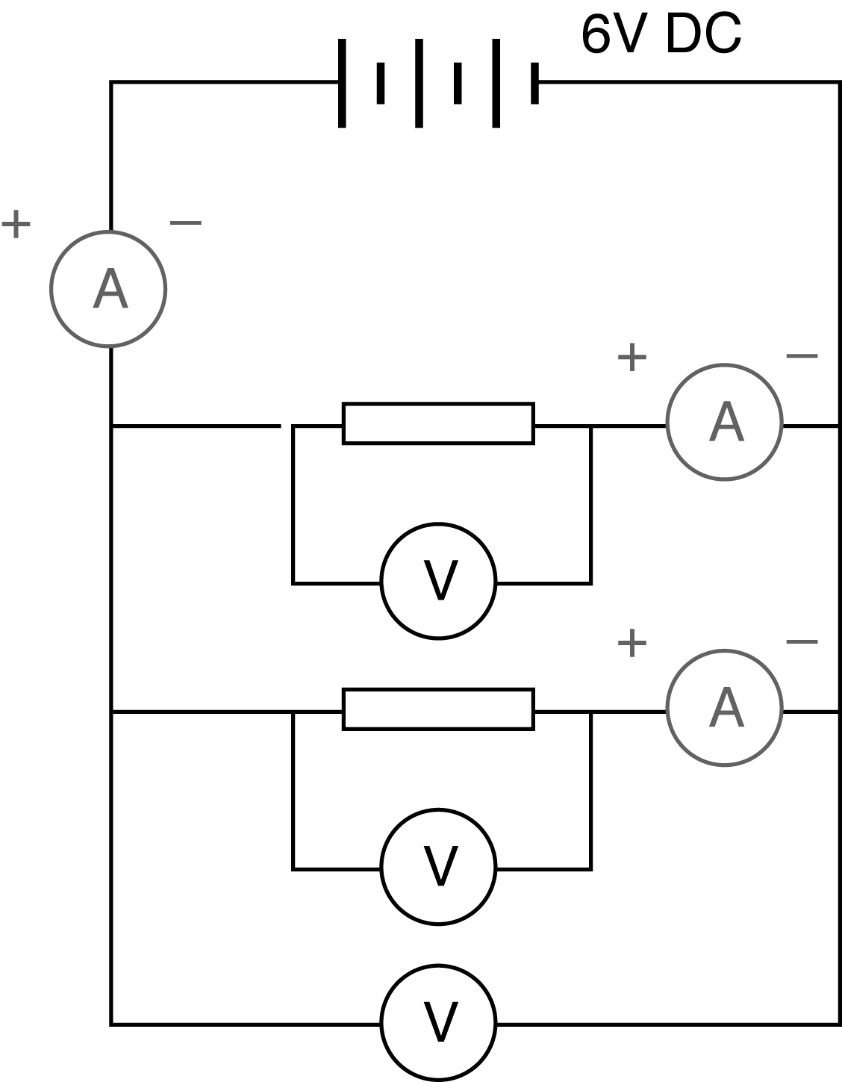
3. Finally, add the third resistor, in parallel with the first two.
Once again, measure the total potential difference in the circuit, the total current across both resistors, and the current and potential difference for each resistor.
Record this last set of results.

27 Parallel circuits
continued

DATA & ANALYSIS
Summarise your results in a suitable table. Use your results to calculate the value of each resistor and to determine the relationship between:
• the individual current for each resistor and the total current for the circuit
• the individual potential difference for each resistor and the total potential difference for the circuit
• the individual resistance of a resistor and the total resistance for the circuit.

CONCLUSION
Summarise the relationships you have discovered, or confirmed, for current, potential difference and resistance in a parallel circuit.

QUESTIONS
1. Do the values found for the resistance of each individual resistor match the indicated value?
Check the expected values with your teacher and account for any discrepancies.
2. Make a list of the sources of errors that could reasonably affect the results of this experiment. Comment on each.

